Migraines and Contraceptives
Name
Institution

- What is the structure activity of triptans?
The triptans contain an indole structure which is identical to the neurotransmitter 5-HT. The 5-HT acts as a mediator during the pathogenesis of migraine. Triptans is an acute treatment to patients experiencing migraine Headaches (Wilt, Nguyen and Roberts 2017). The figure below shows the indole structure of the triptan drugs. The triptans structures are designed from a structure of a 5-HT in order to acquire 5-HT receptors hence the identical indole structure. Therefore, they are cable of increasing the binding ability of the compound as well as the efficacy particularly with a 5-HT_{1D} receptor.
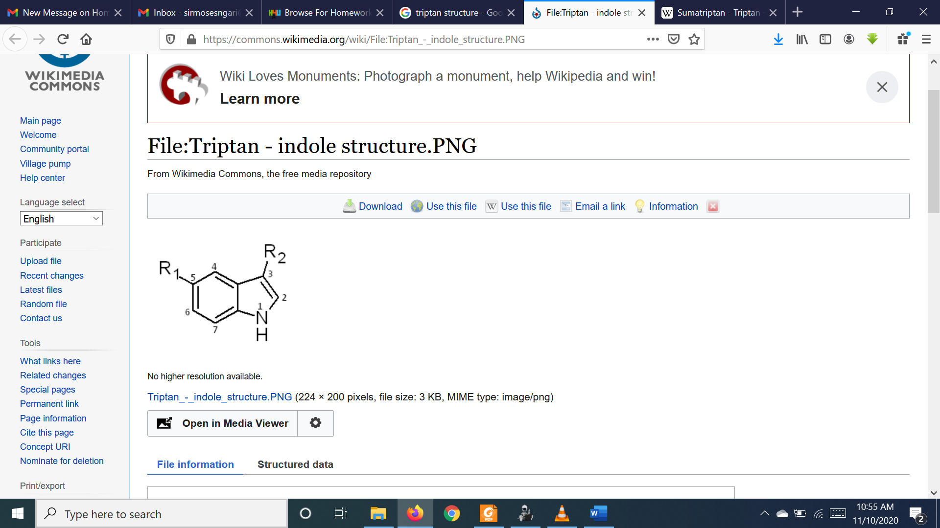

- If a person presented to the pharmacy with a headache or migraine, when is it necessary to immediately refer to the doctor? (i.e. what are the red flags?)
The pharmacists may refer patients with serious underlying pathology. Some of these headaches are caused by the trauma commonly referred to as posttraumatic headaches. Some of the red flags for the secondary disorders include the onset headache, that tend to occur after 50 years of age. Other red flags include an increased level of severity of headache referred to as thunderclap headache. Positional headache where patients experience headache as a result of changing their body position. A patient may also be suffering from headache started by the exertion which begins while an individual is coughing sneezing as well as straining. Patients may also experience headache that fails to go away and systemic systems that include the fever, chills, weight loss and night sweats.

- Are there any complementary therapies that are effective for the treatment of migraines?
Yes. Complimentary therapies such as message, spinal manipulation and acupuncture may be quite beneficial and effective to persons suffering from migraines. Other complimentary therapies include the relaxation techniques such as deep breathing, progressive relaxation with primary motive of activating the parasympathetic nervous system that tends to counter the effects of stress on blood circulation.
- Why might Ms Atnip be experiencing more frequent migraines?
Ms Atnip might be experiencing more frequent migraines because she of stress which might cause the imbalance in the brain chemicals including the serotonin that aids in the regulations of the pain the nervous system. Atnip experienced stress when the condom burst as well as hormonal adjustments in women. Moreover, the medication she took Microlut which is a contraceptive drug. Among the side effects of the drug is the headache that may result to migraines (Vujovic et al., 2016).

- Are women who experience migraine able to take HRT?
The Hormone replacement therapy (HRT) is used to treat patients experiencing hot flushes as well as sweats. It is not advisable for women who have migraines to take HRT since it would trigger migraines. They are advised to utilize patches and gel because such HRT tend to ensure the hormone levels are more stable (Kotsopoulos et al., 2018).

6. What are the HRT options for women who have had a hysterectomy compared to the options for women who still have their uterus? Why are they different?
The women who have undergone the hysterectomy where the uterus including its ovaries has been removed are offered with only the oestrogen. On the other hand, those women still having the uterus but ovaries removed need both the estrogen and progestin (Tomlinson 2018). It is because the estrogen alone is capable of increasing the risk of cancer in the uterus hence progestin is added to eradicate the risk.

References
Kotsopoulos, J., Gronwald, J., Karlan, B. Y., Huzarski, T., Tung, N., Moller, P., ... & Singer, C. F. (2018). Hormone replacement therapy after oophorectomy and breast cancer risk among BRCA1 mutation carriers. JAMA oncology, 4(8), 1059-1065.
Vujovic, S., Ivovic, M., Tančić-Gajić, M., Marina, L. V., Barac, M., Arizanovic, Z., ... & Micić, D. (2016). Contraception in Climacterium. In Frontiers in Gynecological Endocrinology (pp. 153-159). Springer, Cham.
Warhurst, S., Rofe, C. J., Brew, B. J., Bateson, D., McGeechan, K., Merki-Feld, G. S., ... & Tomlinson, S. E. (2018). Effectiveness of the progestin-only pill for migraine treatment in women: a systematic review and meta-analysis. Cephalalgia, 38(4), 754-764.
Wilt, L. A., Nguyen, D., & Roberts, A. G. (2017). Insights into the Molecular Mechanism of Triptan Transport by P-glycoprotein. Journal of pharmaceutical sciences, 106(6), 1670-1679.

